Exp 8

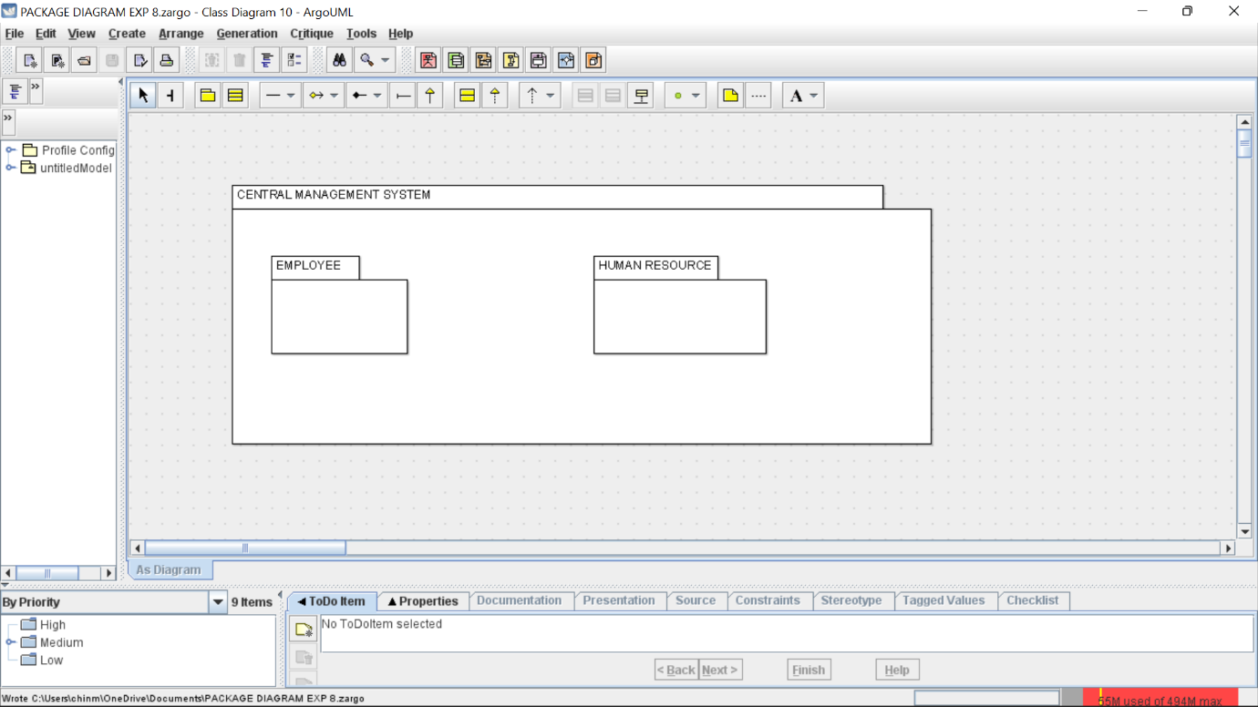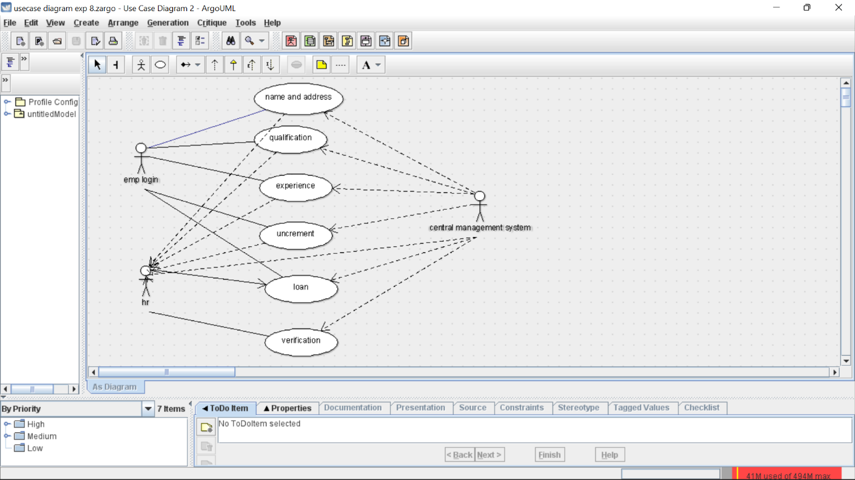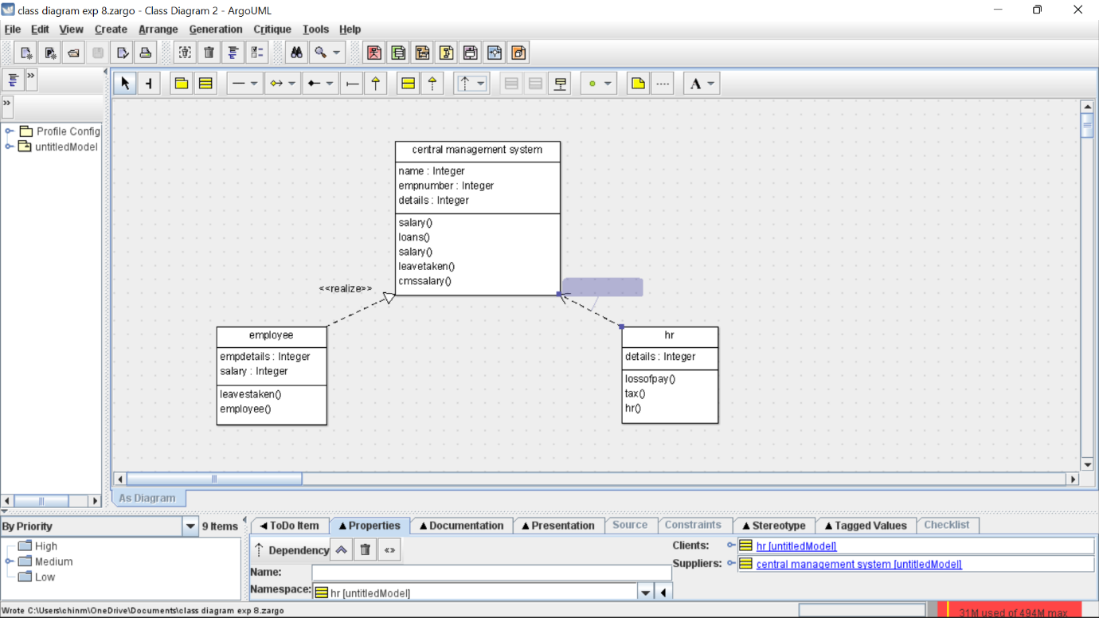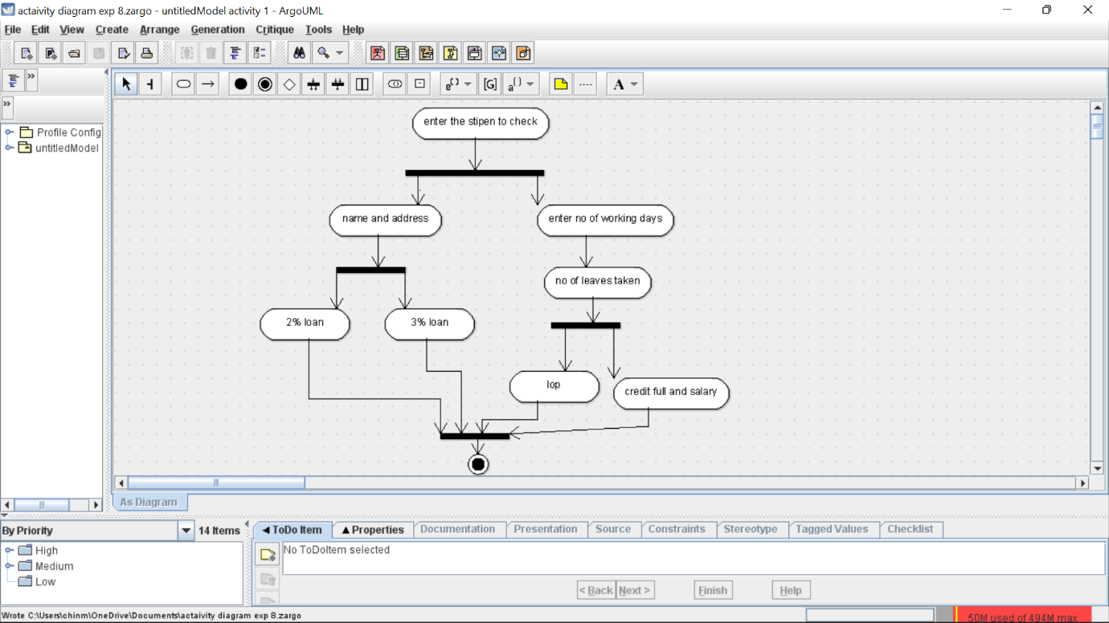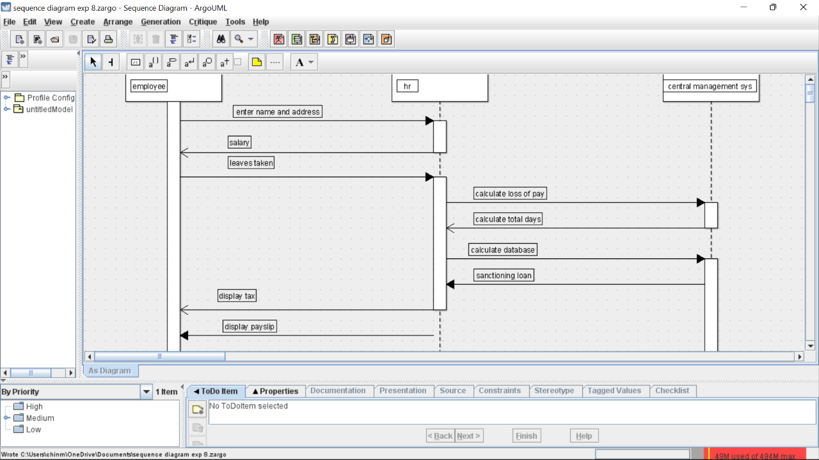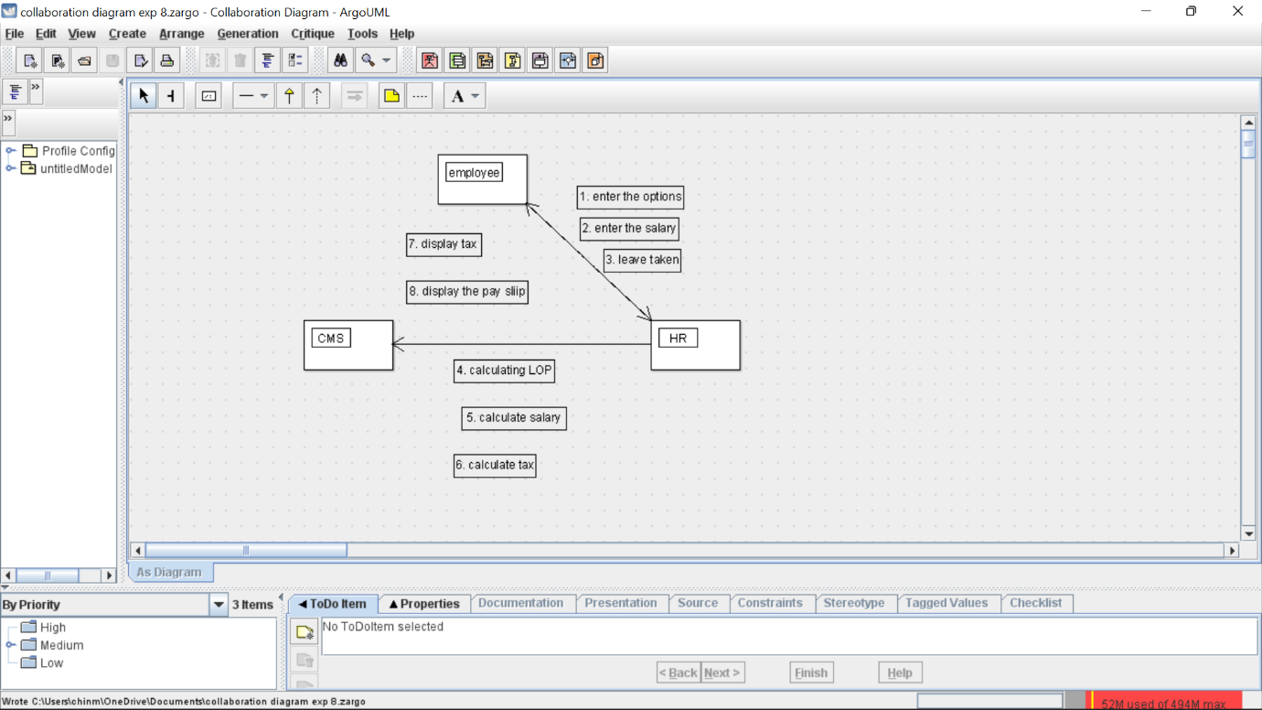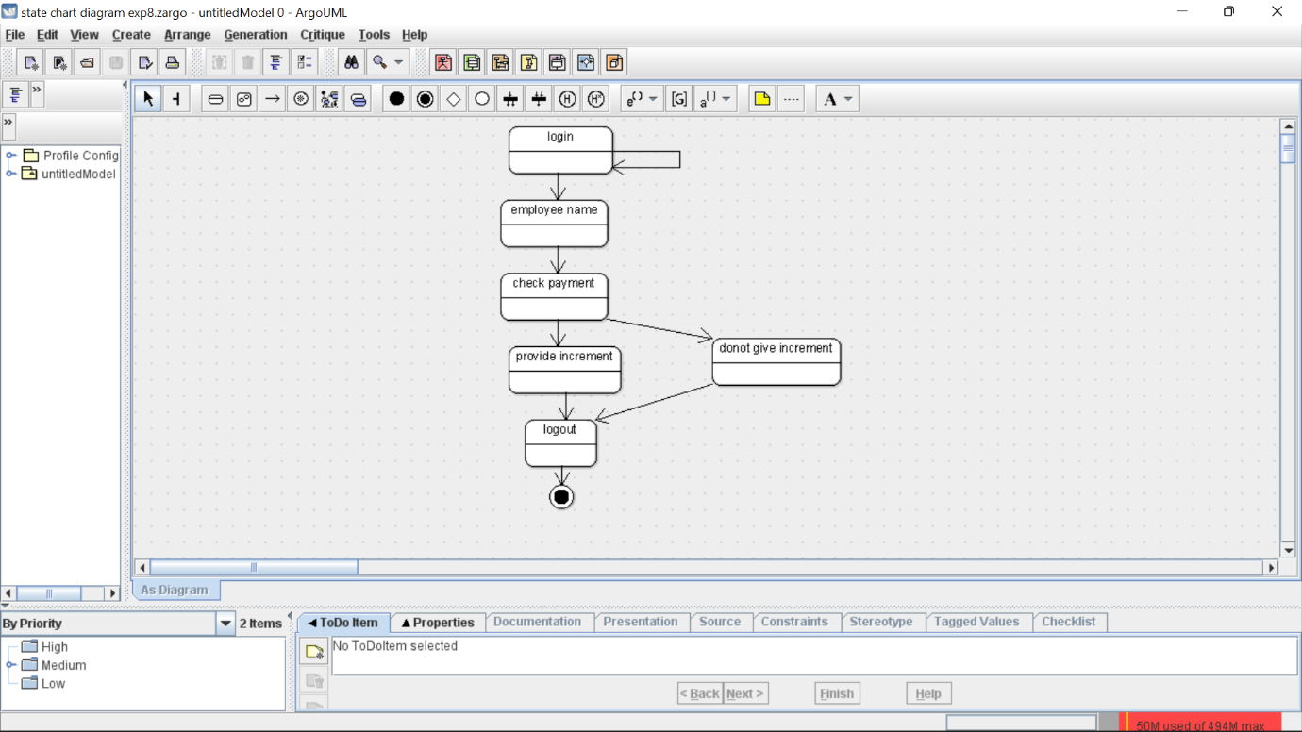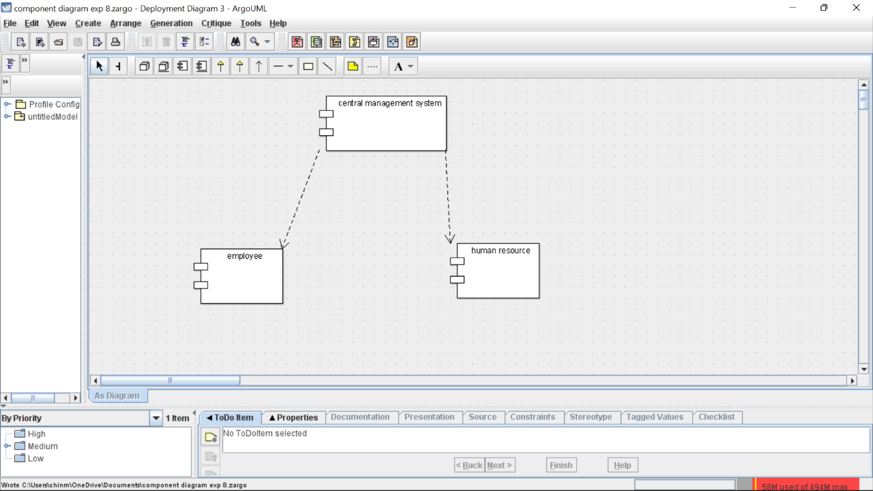skeleton

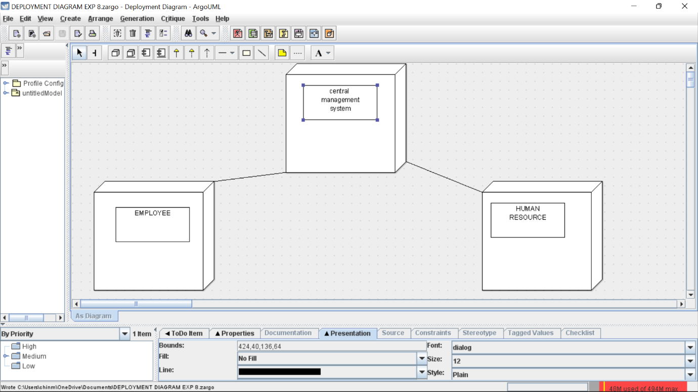

Skeleton

public class central management system {

private Integer name;

public Integer empnumber;

private Integer details;

public void salary() {

}

public void loans() {

}

public void salary() {

}

public void leavetaken() {

}

public void cmssalary() {

}

}

public class employee {

public Integer empdetails;

public Integer salary;

public void leavestaken() {

}

public void employee() {

}

public class hr {

public Integer details;

public void lossofpay() {

}

public void tax() {

}

public void hr() {

}

}